**DEPARTMENT OF ELECTRONICS & COMMUNICATION ENGINEERING**



Analog IC Design

**Experiment-6**

**Submitted by**

**PRATIBHA SINGH**

**602162015**

**M.Tech (VLSI Design)**

**Experiment-6**

**Aim**:

To design a common source amplifier with current mirror load for gain of 10 and analyse its transient characteristics.

**Tool Used:**

LTspice tool

**Theory:**

When the input signal is applied at the gate terminal and source terminal, then the output voltage is amplified and obtained across the resistor at the load in the drain terminal. This is called a common source amplifier.

Common source amplifier is similar to the common-emitter follower of Bipolar Junction transistor. If we use P-channel FET, the polarity of the input voltage will be reversed.

For a NMOS let’s assume

VDD = 1.8V, VT = 0.4V, VGS = 0.6V, Kn = 120µA/V2,

For a PMOS let’s assume

VDD = 1.8V, VT = -0.4V, VGS = 0.6V, Kp = 120µA/V2,

Which gives a value of (W/L) = (29.6) for 1mA ID.

Also, for these values’ gm is attained as 10mΩ-1, therefore for gain 10, RD is taken as 1KΩ.

The value of VDS should be maintained above (VGS - VT = 0.6 - 0.4 = 0.2V) for the transistor to stay in saturation region.

As for M3, the width is taken as 296µm and the length is taken as 10µm and for M1 and M2, the width is taken as 10 µm and the length is taken as 10 µm.

**Circuit Schematic:**

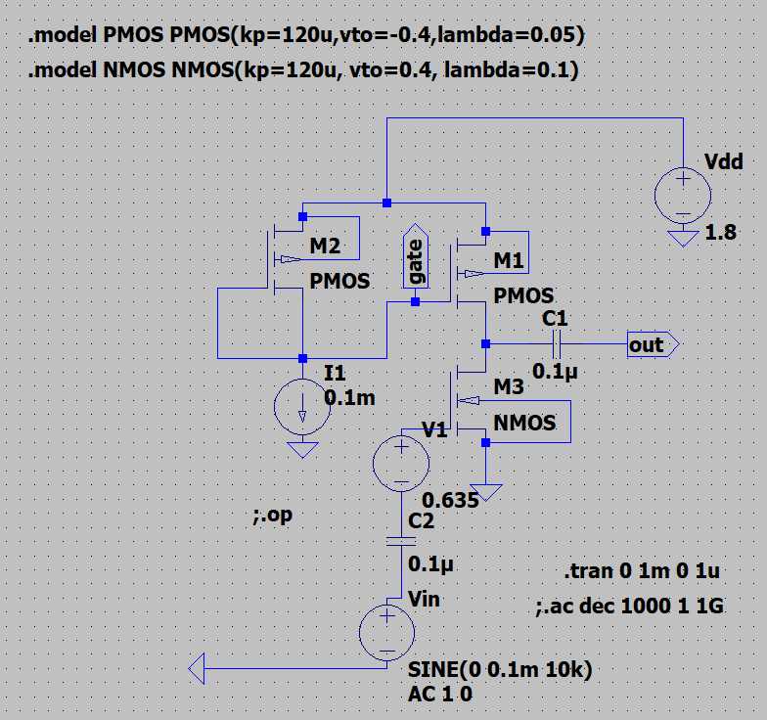

**DC Operating Point**

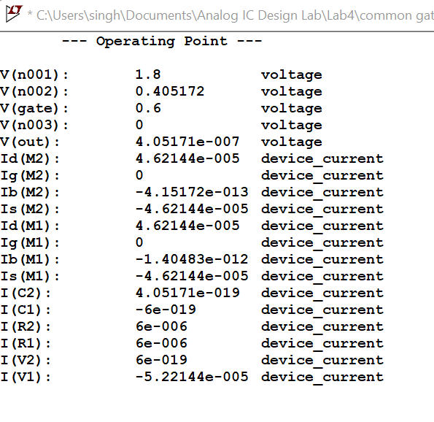

**Output Waveforms:**

Transient Response:

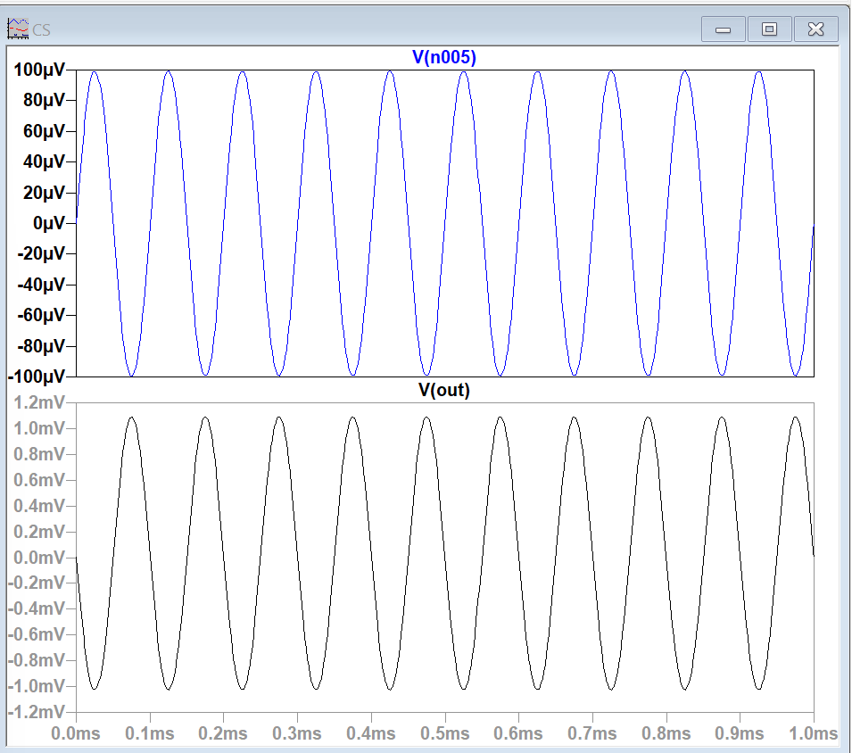

**Result:**

The circuit is designed for a gain of 10 and the output is verified to be correct.